- ITEM #: 842CN Keeper, Slide, Alice Clip
- ITEM DESCRIPTION: Meets or exceeds MIL Spec. MIL-H-9890 Type XI Metal belt clip with pull-up vertical slide ALICE keeper. MADE IN CHINA- WILL NOT MEET MIL-SPEC Requirement.
- COMPOSITION: Tempered Steel - ASTM 1566
- Measurements: The steel has been anodized with for corrosion resistance and appearance.

- PACKAGING: Primarily offered in bulk quantities of 1000 pieces. Item is TYPICALLY shipped in a single reinforced cardboard box.
Box specifications are: 44 US Pounds = 19.958 Kgs
Width: 12” (30.48 CM)
Depth: 12” (30.48 CM)
Height: 10” (25.4 CM)
Cu ft volume: 0.833
- MARKINGS: NONE or THECLIP.COM
- ITEM PHOTOGRAPHS:
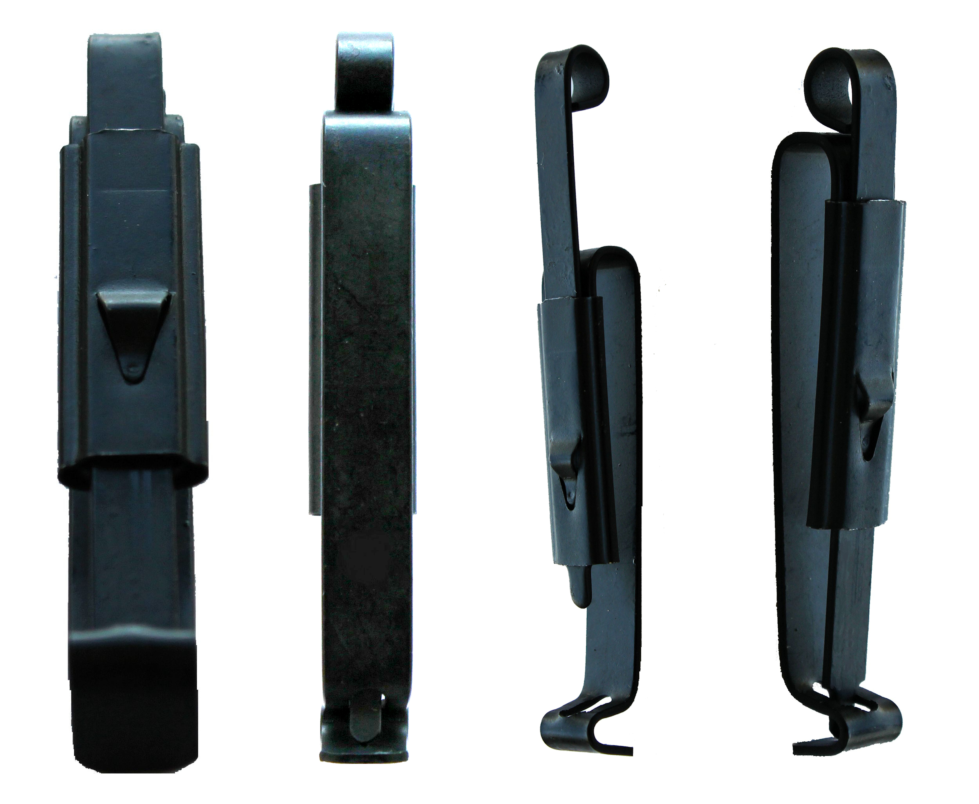
- SAFETY: All material and finished components are RoHS compliant.
Completed parts are wheel buffed along all edges prior to plating in order to remove whiskers.

